SELECT CEIL(46.29)FROM DUAL;



SELECT CEIL(-46.9)FROM DUAL;



SELECT CEIL(46/3)FROM DUAL;



SELECT FLOOR(46.76)FROM DUAL;



SELECT FLOOR(-46.3)FROM DUAL;



SELECT FLOOR(46/4)FROM DUAL;



SELECT SQRT(625)FROM DUAL;



SELECT SQRT(46)FROM DUAL;



SELECT ABS(46.29)FROM DUAL;



SELECT ABS(-46.14)FROM DUAL;



SELECT ABS(-46)FROM DUAL;



SELECT SYSDATE AS NOW FROM DUAL;

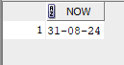

SELECT TO_CHAR(SYSDATE, 'dd-mm-yyyy')AS DATE_FORMAT,TO_CHAR(SYSDATE,'hh:mm:ss') AS TIME_FORMAT FROM DUAL;



SELECT SYSTIMESTAMP FROM DUAL;



SELECT LEAST('HARRY','HARRIOT','HAROLD')FROM DUAL;



SELECT GREATEST('HARRY','HARRIOT','HAROLD')FROM DUAL;



SELECT TRIM('TRIM ME')FROM DUAL;



SELECT TRIM('I LOVE INDIA')FROM DUAL;



SELECT RPAD('NAVEEN AJESH',15,'X') FROM DUAL;



SELECT RPAD(123,6,0) FROM DUAL;



SELECT REVERSE('uoyevol i')FROM DUAL;



SELECT CASE WHEN'RACECAR'=REVERSE('RACECAR') THEN 'PALINDROME' ELSE 'NOT PALINDROME' END AS RESULT FROM DUAL;

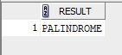

SELECT LENGTH('ORACLE DATABASE') FROM DUAL;



SELECT 'ORACLE'||' '||'SQL'||' '||'IS'||' '||'POWERFUL'||' '||'AND'||' '||'FLEXIBLE' FROM DUAL;

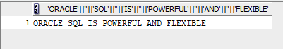

SELECT CONCAT('NAVEEN','AJESH') FROM DUAL ;



SELECT SUBSTR('INDIA IS MY COUNTRY',7,2) FROM DUAL;

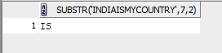

SELECT SUBSTR('NAVEEN AJESH',3,3) FROM DUAL;



SELECT SUBSTR('SUBSTRING',1, 3) FROM DUAL;

